
School: |  | School of Engineering and Technology
Program: |  | BCA / Bsc Data Science
Year: | ^{2nd} | Semester: | 3rd
Academic year: |  | 2024-2025

Course Code: |  |  | CMP304 | Course Name: |  | Introduction to Web Designing and PHP
A Report submitted on Certification Course
Enrollment Number : 23000533
Student’s Name : Aryan Bhupendrabhai Jadav
Batch : D

1. | Name of Topic: Laravel Framework for Beginners
2. | Course Link :  https://alison.com/course/laravel-framework-for-beginners
3. | Screen Shots :  Registration/Login  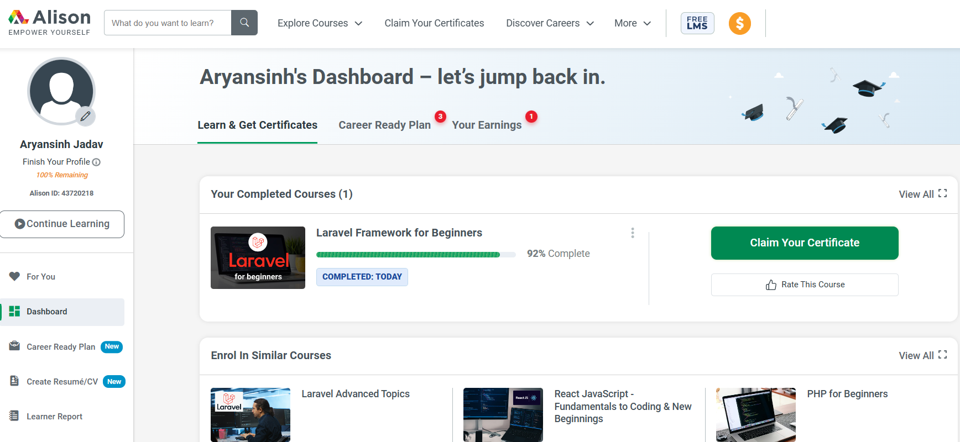  1.Module :1 Introduction to Laravel  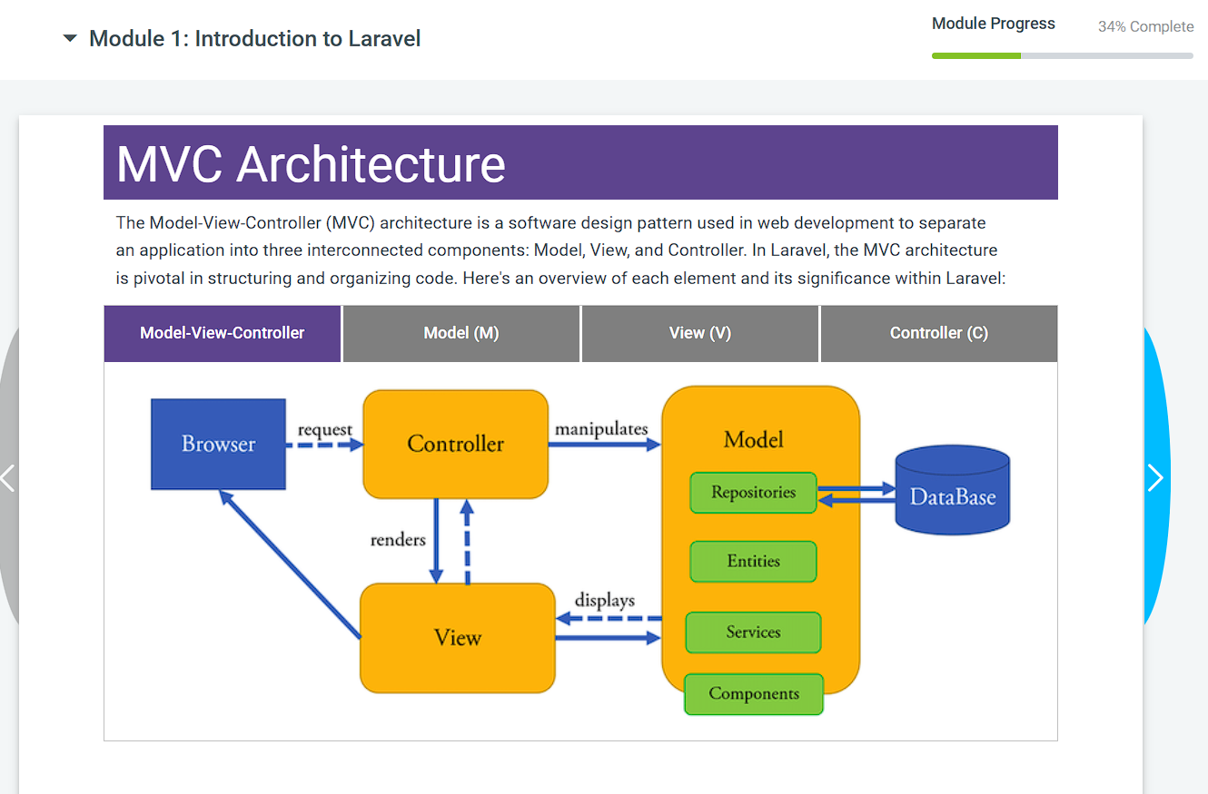  2. Advantages of Laravel  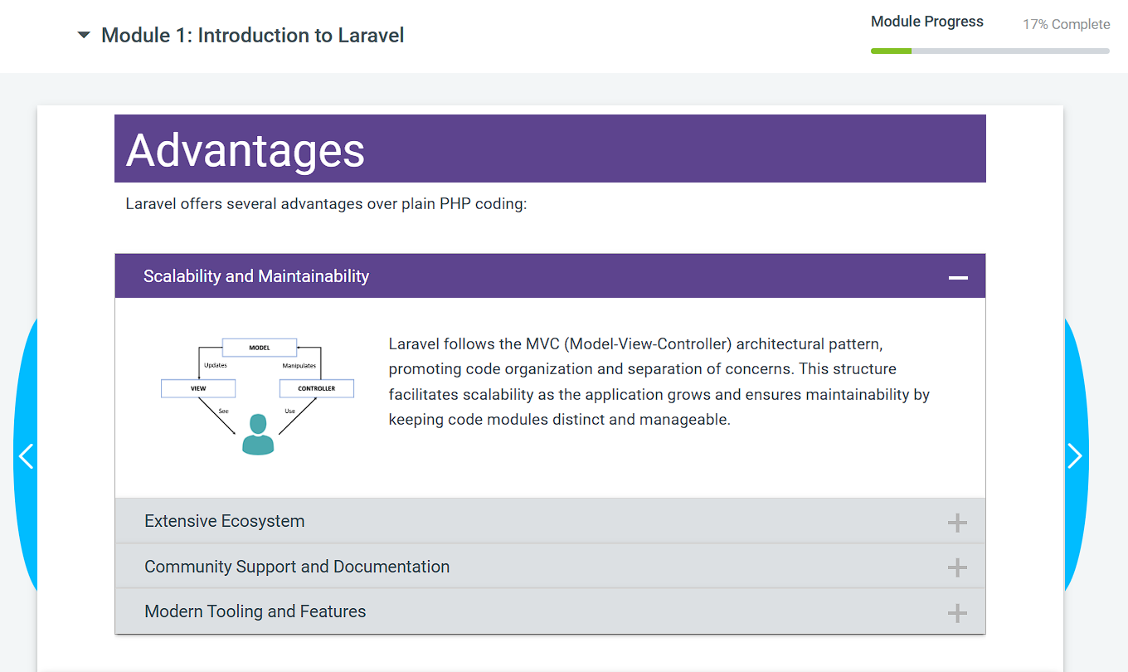  3. Purpose of Laravel  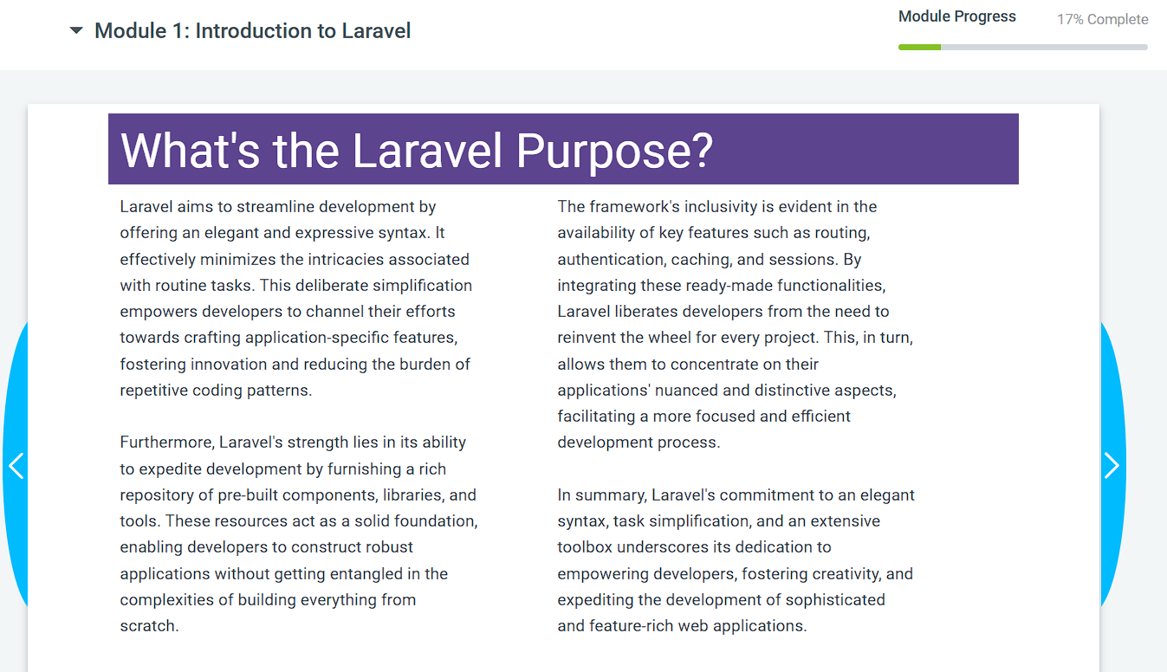  4. Course Objectives(introduction)  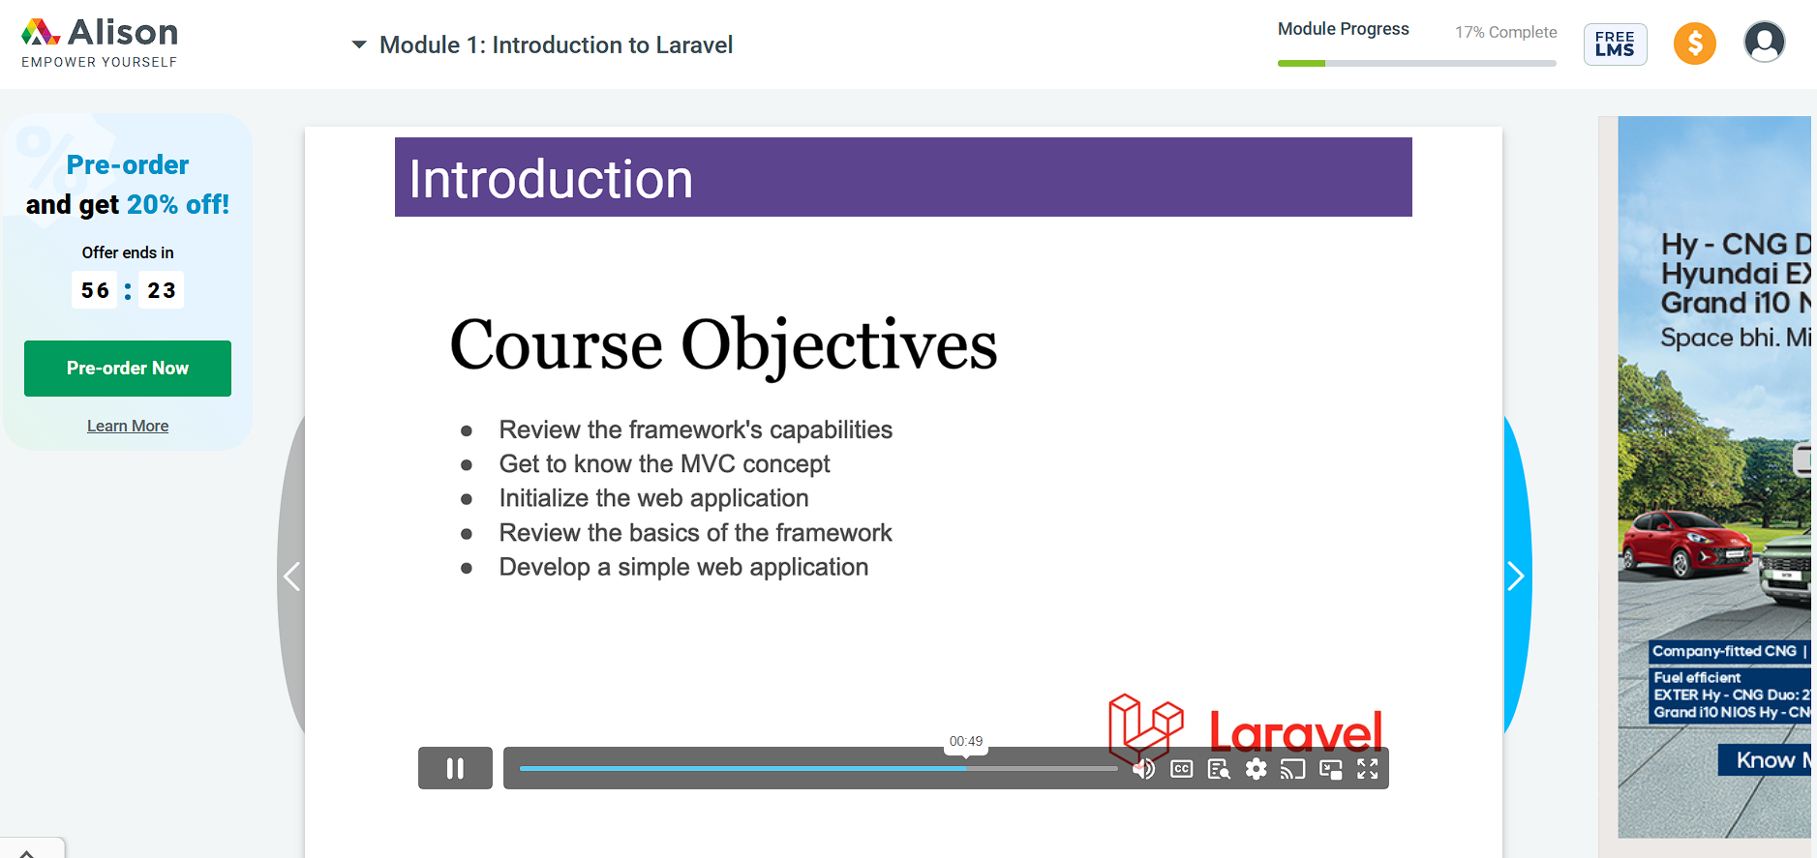  5. MVC Architecture  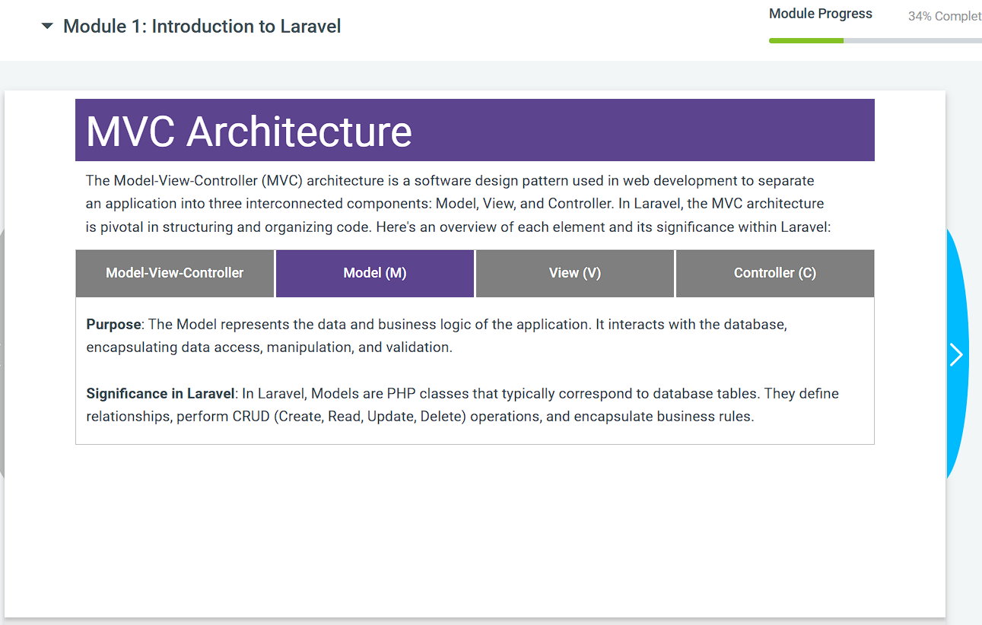  6. Significance of MVC in Laravel  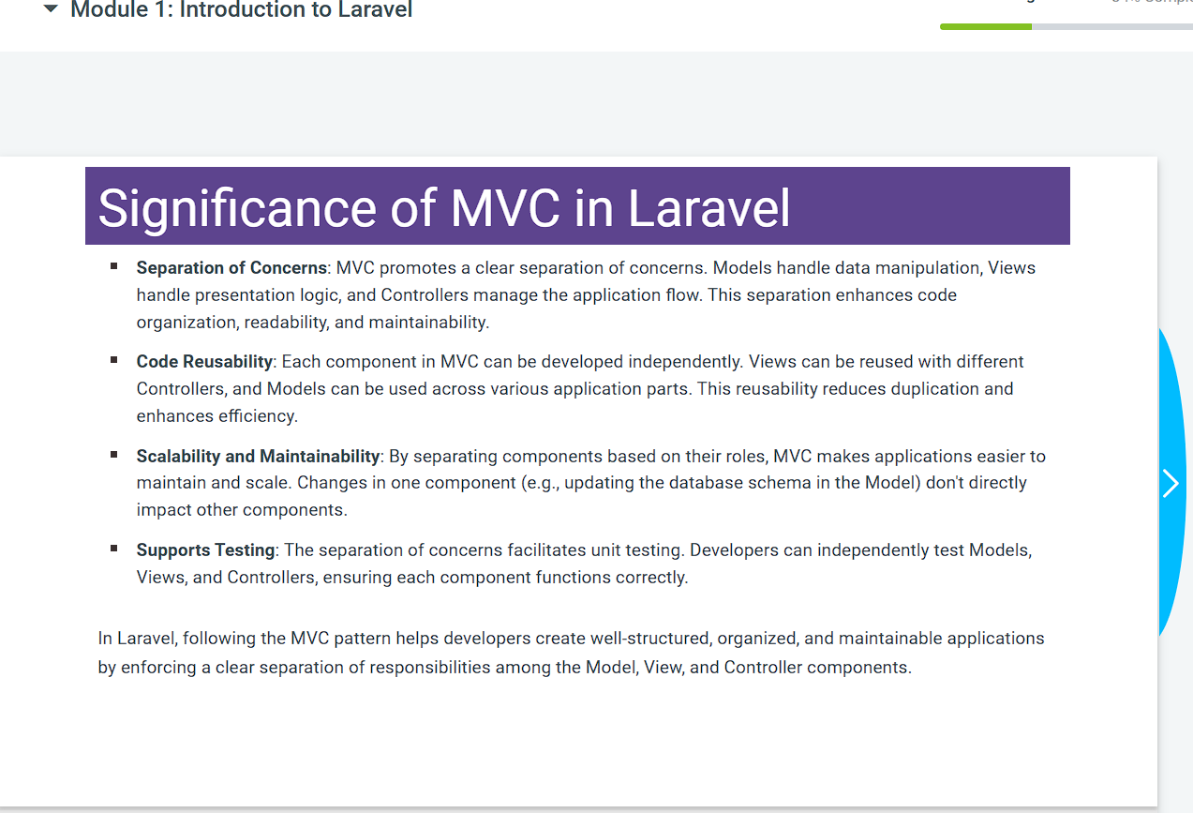  7. Laravel Framework Key Folders  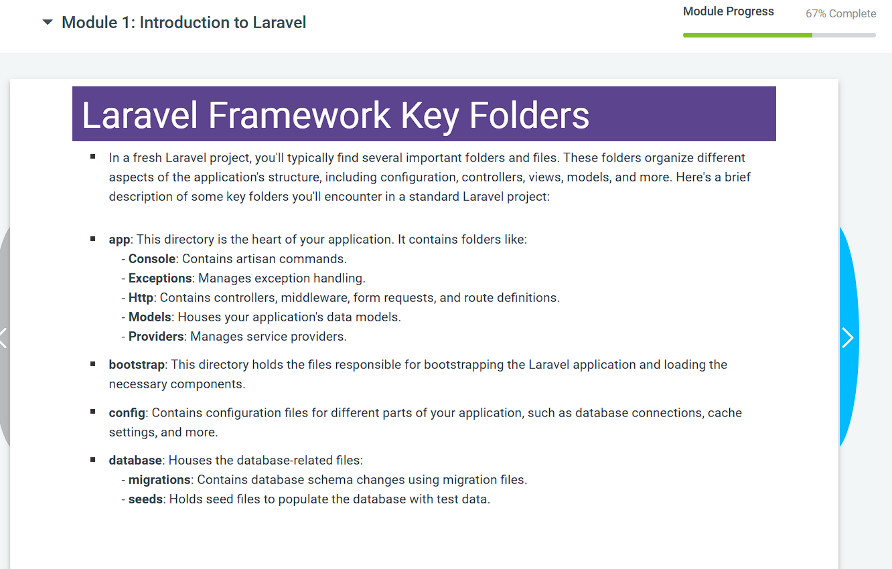  8. Laravel “App” Folder Structure  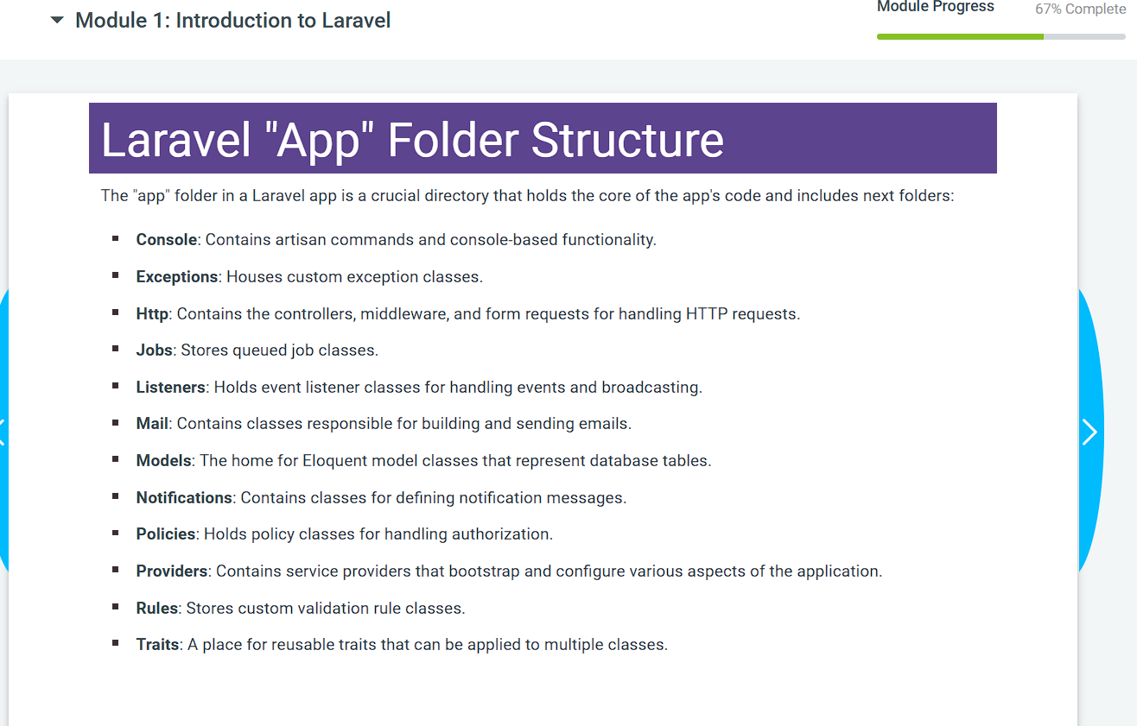  9. Module 2:Web Application Developing  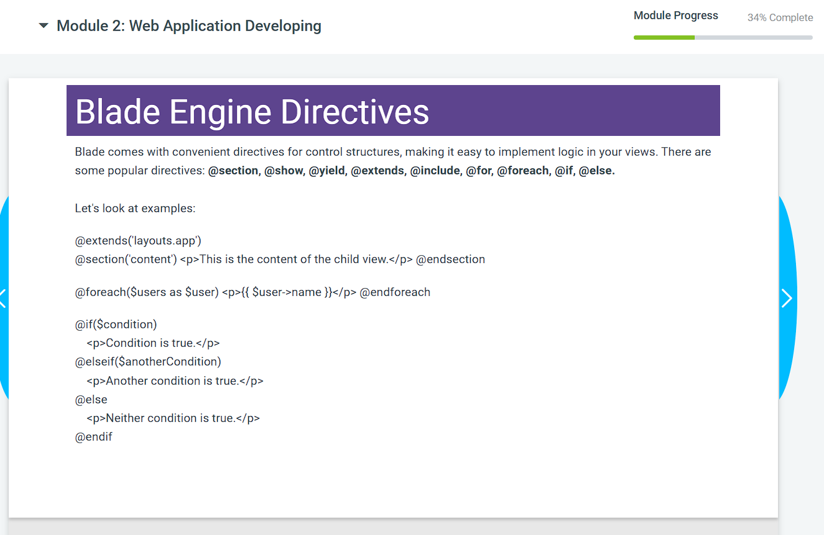  10. Controller Introduction  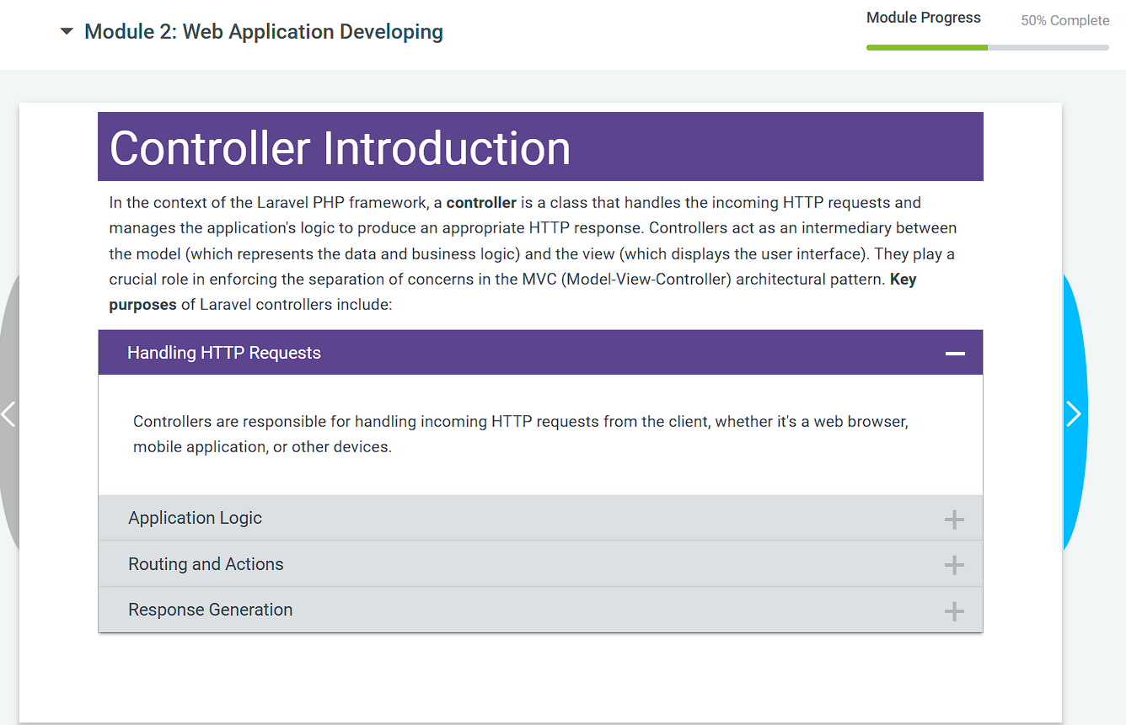  11. Define Controller  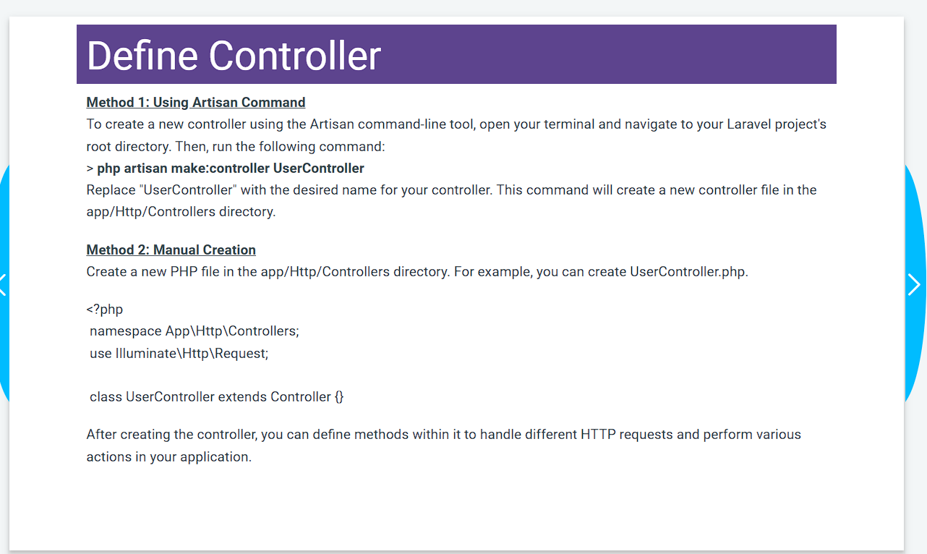  12. Routing Introduction  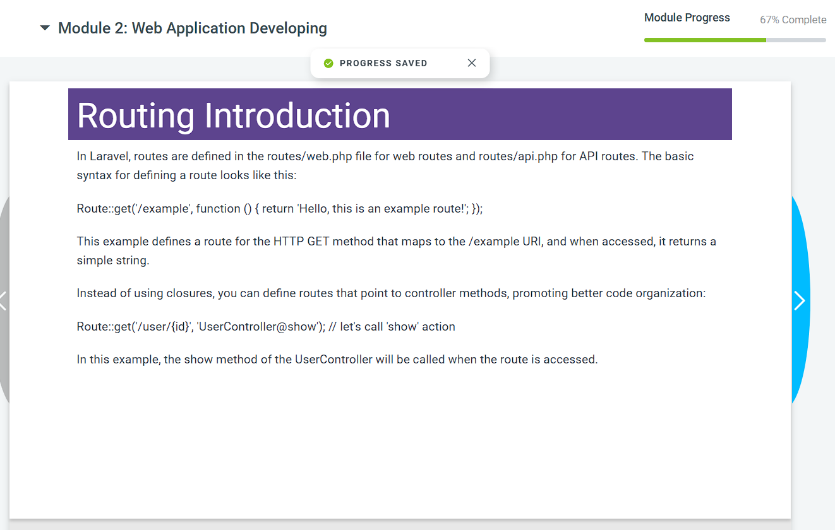  13. Lesson Summary of module 2  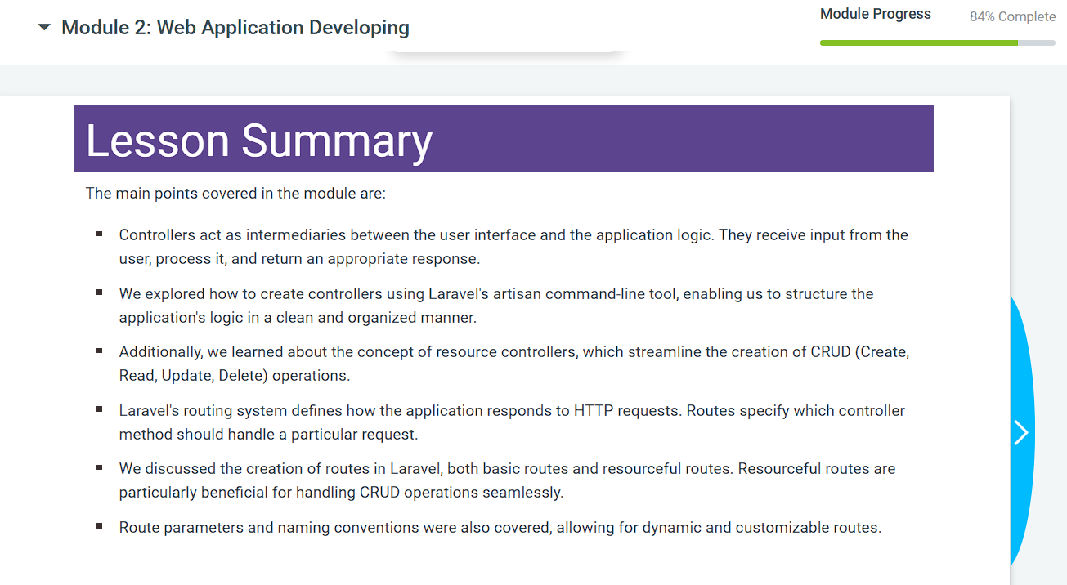
4. | Outcome of You Course in your Words:  The Course is very helpful and knowledgeable.I learned so many things about Laravel and MVC Architecture,Laravel framework and Web application developing & Controller.
5. | Cerificate of Your Course Completion:  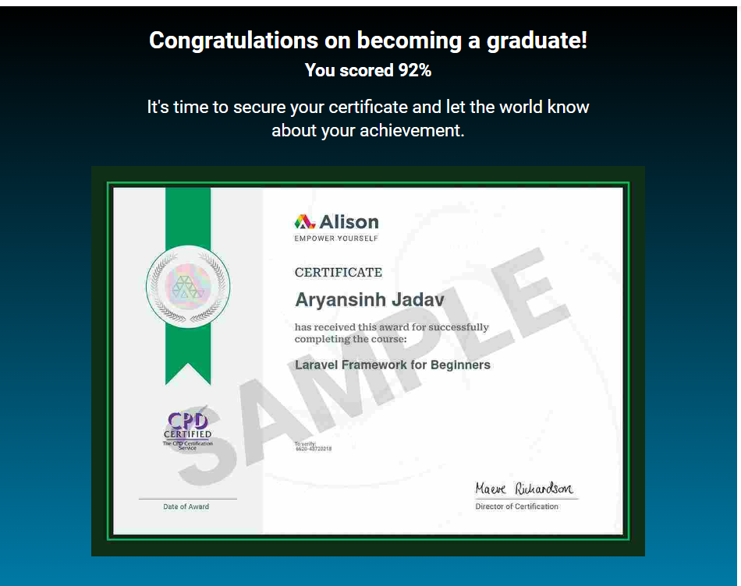
Submitted to:

Ms. Darshana Makani (Course- In charge)
Mr. Dhaval Mehta (Program Chair)

